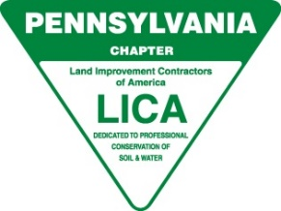

**Pennsylvania LICA Board Meeting- AGENDA**

**March 3, 2022 – State College PA**

* **Call to Order & Invocation:** Evelyn Cottrell
* **Pledge of Allegiance**: All
* **Roll Call-Quorum**: Joanie Micsky
* **Approval of Minutes**: Motion:__________ 2nd __________
* **Presentation of Treasurer’s Report**: Joanie Micsky – Motion: _________ 2nd _________
* **Officer’s**: Chris Moore, - President

Jeremy Pruskowski – Vice President

Evelyn Cottrell – Chairman of the Board

Ron Roncaglione – Treasurer

* **Executive Director:**  Report attached to review

* **Committee Reports:**
* **Associates** – *Joanie Micsky-New Associate Addition to Board*
* **Awards**/**Scholarship**– *Evelyn Cottrell & Nancy Micsky*
* **Education, Training & Safety** – *Chris Moore*
* **Insurance Program –** PRINS INSURANCE TO UPDATE
* **Legislative & LRP** – *Dan Micsky*
* **Membership** – *Joanie Micsky*
* **Picnic –** *Barry Mutzabaugh Jr.,/Dan Micsky*
* **On-Site Waste Management** – *Dan Micsky*
* **Old or Unfinished Business:**
* Make a Wish Event Planning
* **New Business:**
* **Additional Comments from Board Members:**
* **Adjournment: Motion _________________ 2nd _____________________**

**next meeting ____________**