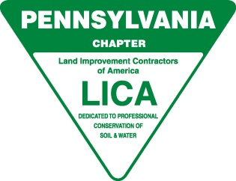

**Pennsylvania LICA ANNUAL Meeting- AGENDA**

**State College, PA - March 3, 2022**

**Call to Order:** President, Chris Moore

1. **Welcome to Contractor Members, Guests and Associates by President**
2. Vote to approve minutes from March 20, 2021 meeting in State College PA
3. **Executive Director:**
4. **Chairman of the Board:**
5. **Old Business:**
6. **New Business:**
7. Nominations and election of officers –
8. Update from the National Convention in San Antonio in February
9. Updated Benefits (new sheet attached)
10. VA Work Training Program – Chris Wagner, LICA President will speak to that
11. **Additional Comments:**
12. **Adjournment**