


paLICA NEWS

MEMBERS’ FALL 2020 EDITION
Monday, September 9, 2019
Earthborne Inc., Warrington, PA, 8am – 4pm
MUST RSVP BY 9/2/19 – CLASS SIZE IS LIMITED TO THE FIRST 30 PEOPLE WHO RESPOND…NO CHARGE AND LUNCH IS INCLUDED. (SEE PAGE 2 TO REGISTER)
PENNSYLVANIA LICA BOARD OF DIRECTORS
PRESIDENT
CHRIS MOORE

VICE PRESIDENT
CORY STUCHAL

TREASURER
RON RONCAGLIONE

CHAIRMAN
EVELYN COTTRELL
BOARD MEMBERS
DAN MICSKY
GARY THEURET
JEREMY PRUSKOWSKI
COLLEEN PUTICH (GILBERT’S INSURANCE)
RICHARD G. COTTRELL
BARRY MUTZABAUGH JR.
RICHARD B. COTTRELL
WILLIAM GUISTE
EXECUTIVE DIRECTOR & NEWSLETTER EDITOR
Joanie Micsky
775 MERCER RD, GREENVILLE PA 16125
724-866-1082
PENNSYLVANIALICA@GMAIL.COM

WELCOME OUR NEWEST MEMBERS TO PALICA!
CHARLES CORBY & SONS EXC CHERRY TOWNSHIP
CHARLES CORBY DIANE FITZGERALD
306 SR 292E 11961 ROUTE 87
TUNKHANNOCK, PA 18657 DUSHORE, PA 18614
570-996-0794 570-928-9228

CITY OF HAZELTON DPW HANOVER TWP-S. VALLEY COG
40 N. CHURCH ROAD 1267 SANS SOUCI PKWY
HAZELTON, PA 18201 HANOVER TWP, PA 18706
570-459-4962 570-825-1271

OLYMPIC POOLS PAUPACK TWP
ANTHONY SANTARELLI BRUCE CHANDLER
301 S. KEYSER AVENUE 25 DANIELS ROAD
TAYLOR, PA 18517 LAKEVILLE, PA 18438
570-655-5005 570-226-3115



PALICA
775 MERCER ROAD
GREENVILLE PA 16125

To:

UPCOMING EVENTS
- Palica year-end board of directors meeting, Saturday November 14, 2020, Days Inn, State College, PA 1pm

- 2021 ANNUAL LICA WINTER CONVENTON – February 9-13, 2021 Holiday Inn San Antonio Riverwalk (more details to follow-subject to changes)

- PALICA 2014 WINTER MEETING – March 5th & 6th @ Days Inn by Wyndham in State College PA (subject to COVID related changes)

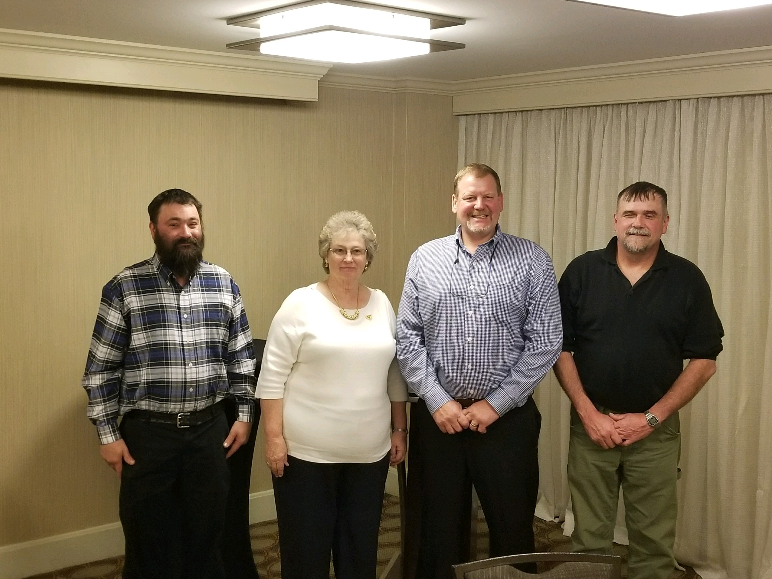
PAGE 1
ASSOCIATE ADVERTISING
GILBERTS RISK SOLUTIONS PAGE 10
PA ONE CALL PAGE 17
EARTHBORNE TRUCKS & EQUIP PAGE 20
BOWER’S GREAT LAKES INTER-DRAIN PAGE 21
EAGLE POWER & EQUIPMENT PAGE 22
UFG/PRINS INSURANCE BACK COVER

INSIDE THIS EDITION WE’RE FOCUSING ON HIGHLIGHTING CONTRACTOR MEMBERS
FEATURES:
  - Newest Members to PALICA COVER
  - President’s Message Page 1
  - THANK YOU TO UFG/PRINS INSURANCE Page 1
  - Upcoming Events Page 1
  - COVID -19 and face masks Page 2
  - DEPARTMENT OF LABOR GUIDELINES Page 3 – 7
  - Family & Sick Leave Requirement Page 8 - 10
  - How to Handle & Store DEF Page 11 – 12
  - News around PALICA Page 13
  - NEW LICA BENEFITS FOR YOU! Page 14 – 15
  - Safety Watch Page 16 - 18
  - Kids raised in the Industry & the future Page 19

PRESIDENT’S MESSAGE
Hello PALICA Members,
Hope all is well with everyone with
a very different start to the
season this year. I know in different parts of the state, things have not been the same for everyone and not all have been affected the same. I’ve heard about all different scenarios; some out of work still, some were out but are back now and some were never shut down. As we move forward in life and work, remember safety is key. Keep on keeping on - hope the best to everyone in the rest of the busy season.

ON BEHALF OF THE ENTIRE BOARD AND MEMBERSHIP, I’D LIKE TO THANK UFG & PRINS INSURANCE FOR ADDING FUNDS TO THE EDUCATIONAL ACCOUNT OF PALICA, IN THE AMOUNT OF $12,552.98! WE WILL PUT THESE FUNDS TO GREAT USE ONCE WE ARE ABLE TO RESUME ACTIVITIES AND CLASSES! It will also help with the PA Winter State Convention. THANK YOU FOR ALL YOUR SUPPORT!
Christopher Moore

FEATURED PALICA MEMBER #1 - JIM ADDISON
Left: pictures of various job sites
Top: Machines from the business/family shots
Bottom: aerial photo of Jim and Jane’s home stead

Jim and Jane Addison have been an intrical part of what PALICA is today. He became a member of PALICA in 1990 and they have been very involved with the association. He was on the Board of Directors since 1999. He also held the position of Treasurer from 1999 until 2013. He was awarded the 2002 CONTRACTOR OF THE YEAR. Jim has been in business for over 40 years.
Jim graduated from Grove City High School in 1958. He was in the Army for 2 years (1958-61). He then went to work for AT&T Telephone Company as a lineman in White Plains NY in 1961. He then worked for Bell Telephone of PA until he retired in 1991. He worked construction jobs during the day and worked afternoon turn at Bell Telephone
Besides doing contractor jobs, Jim enjoys working on old International Tractors and spending time with his family.
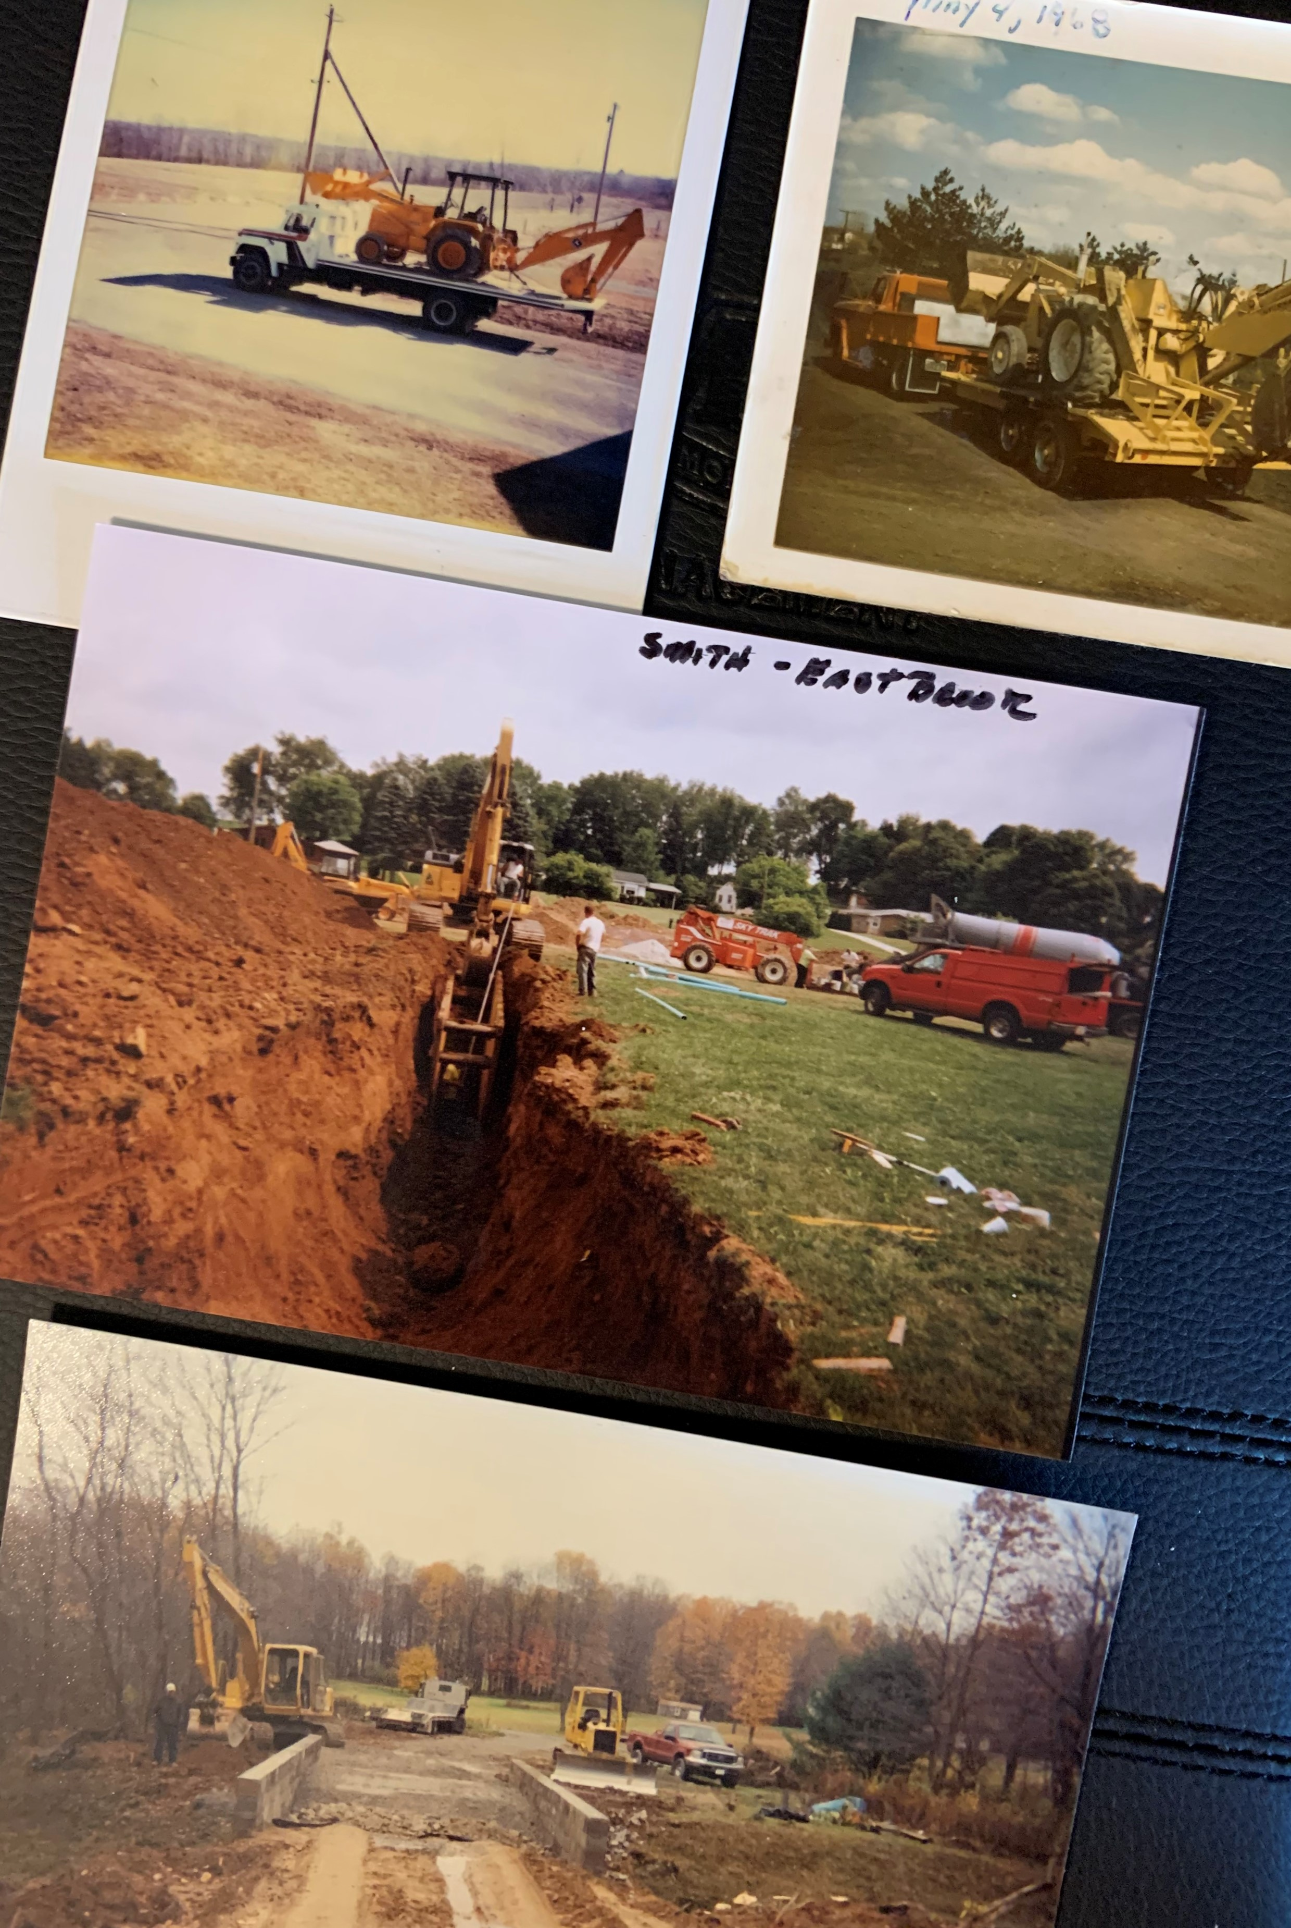
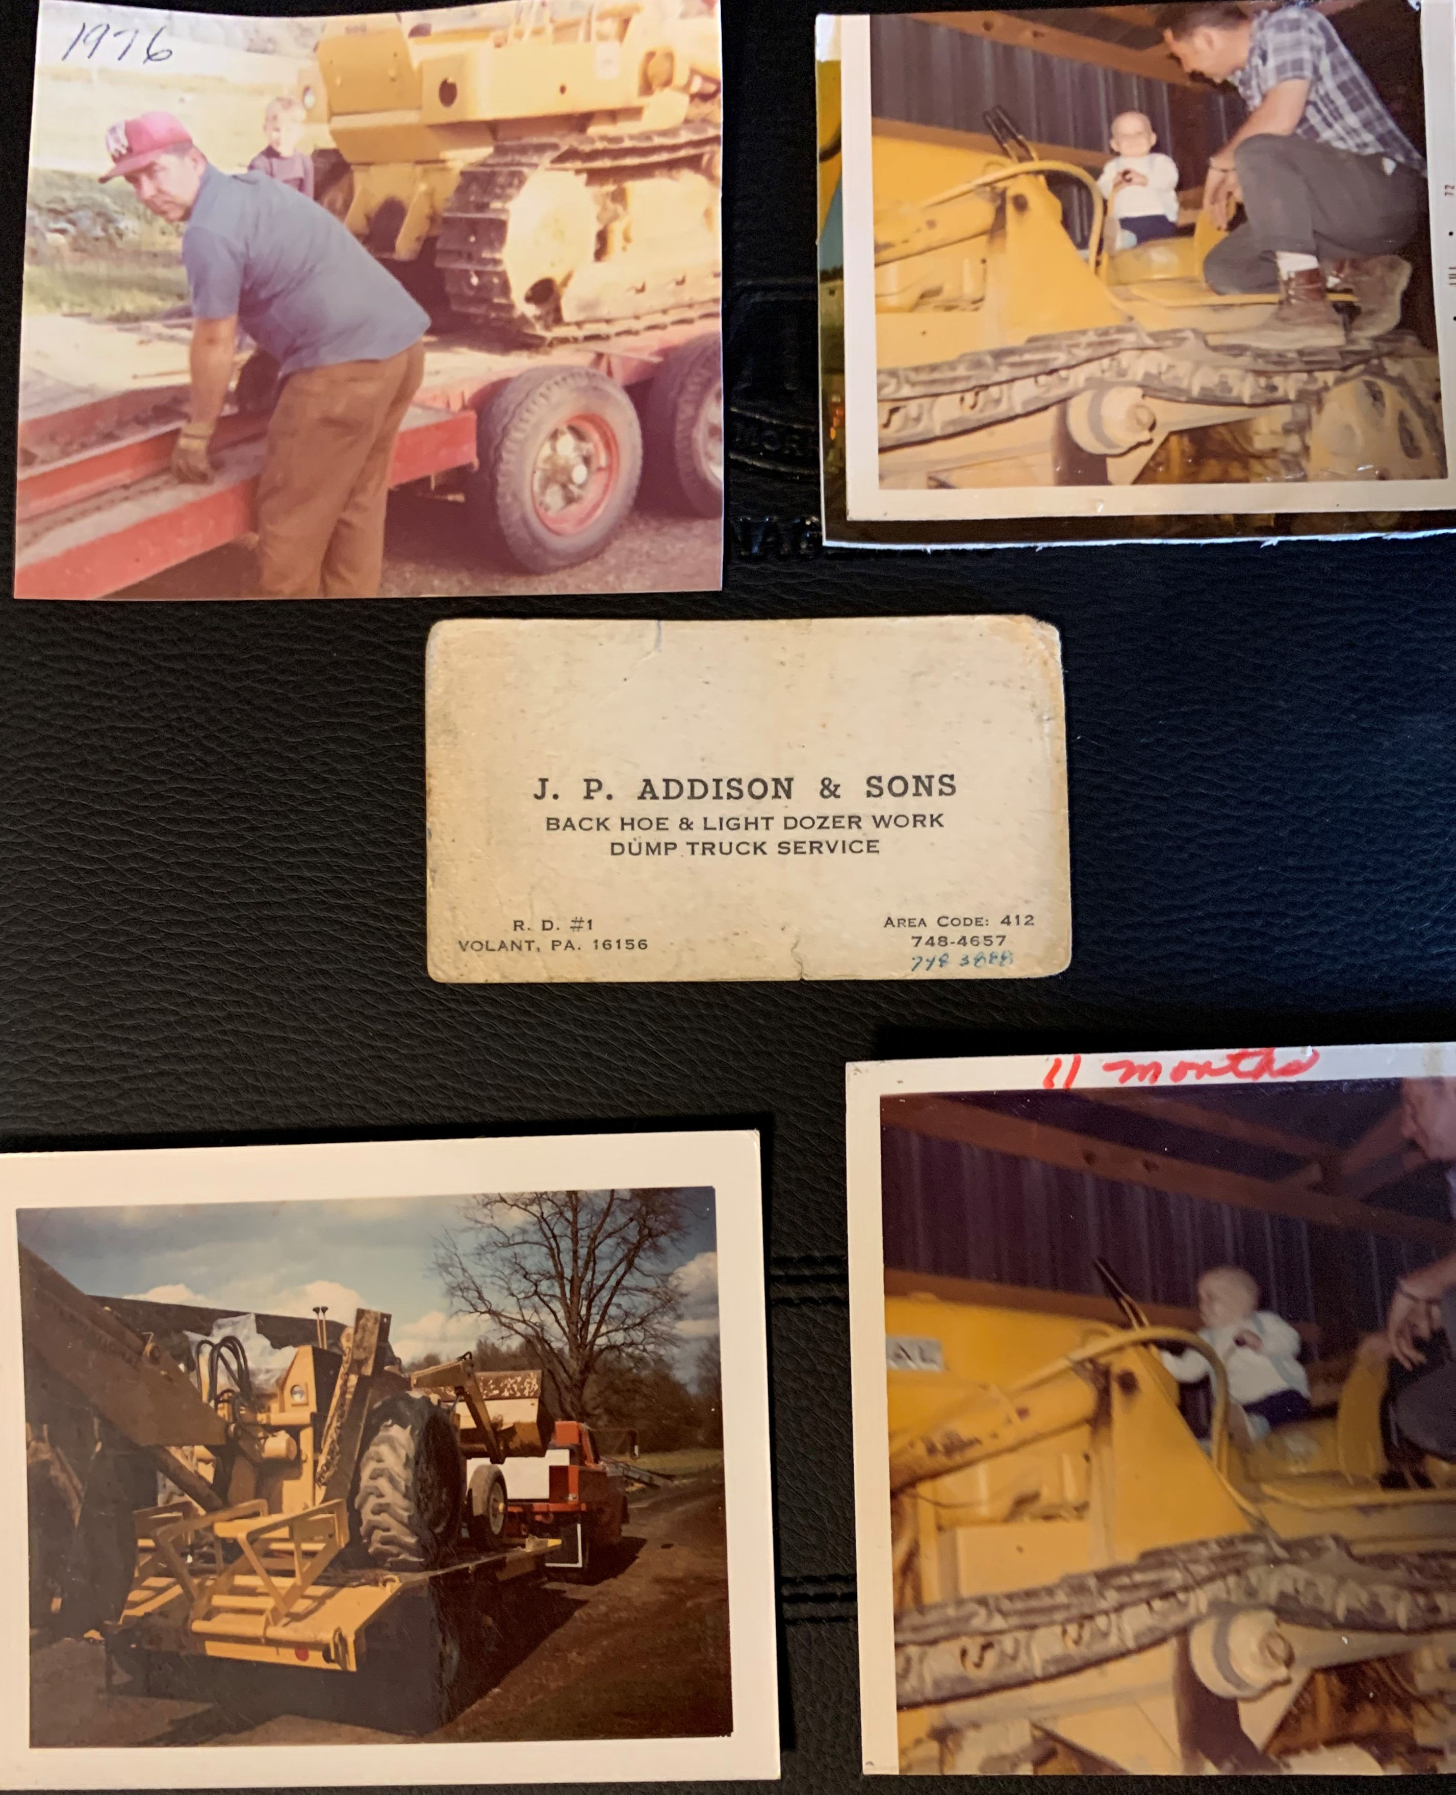
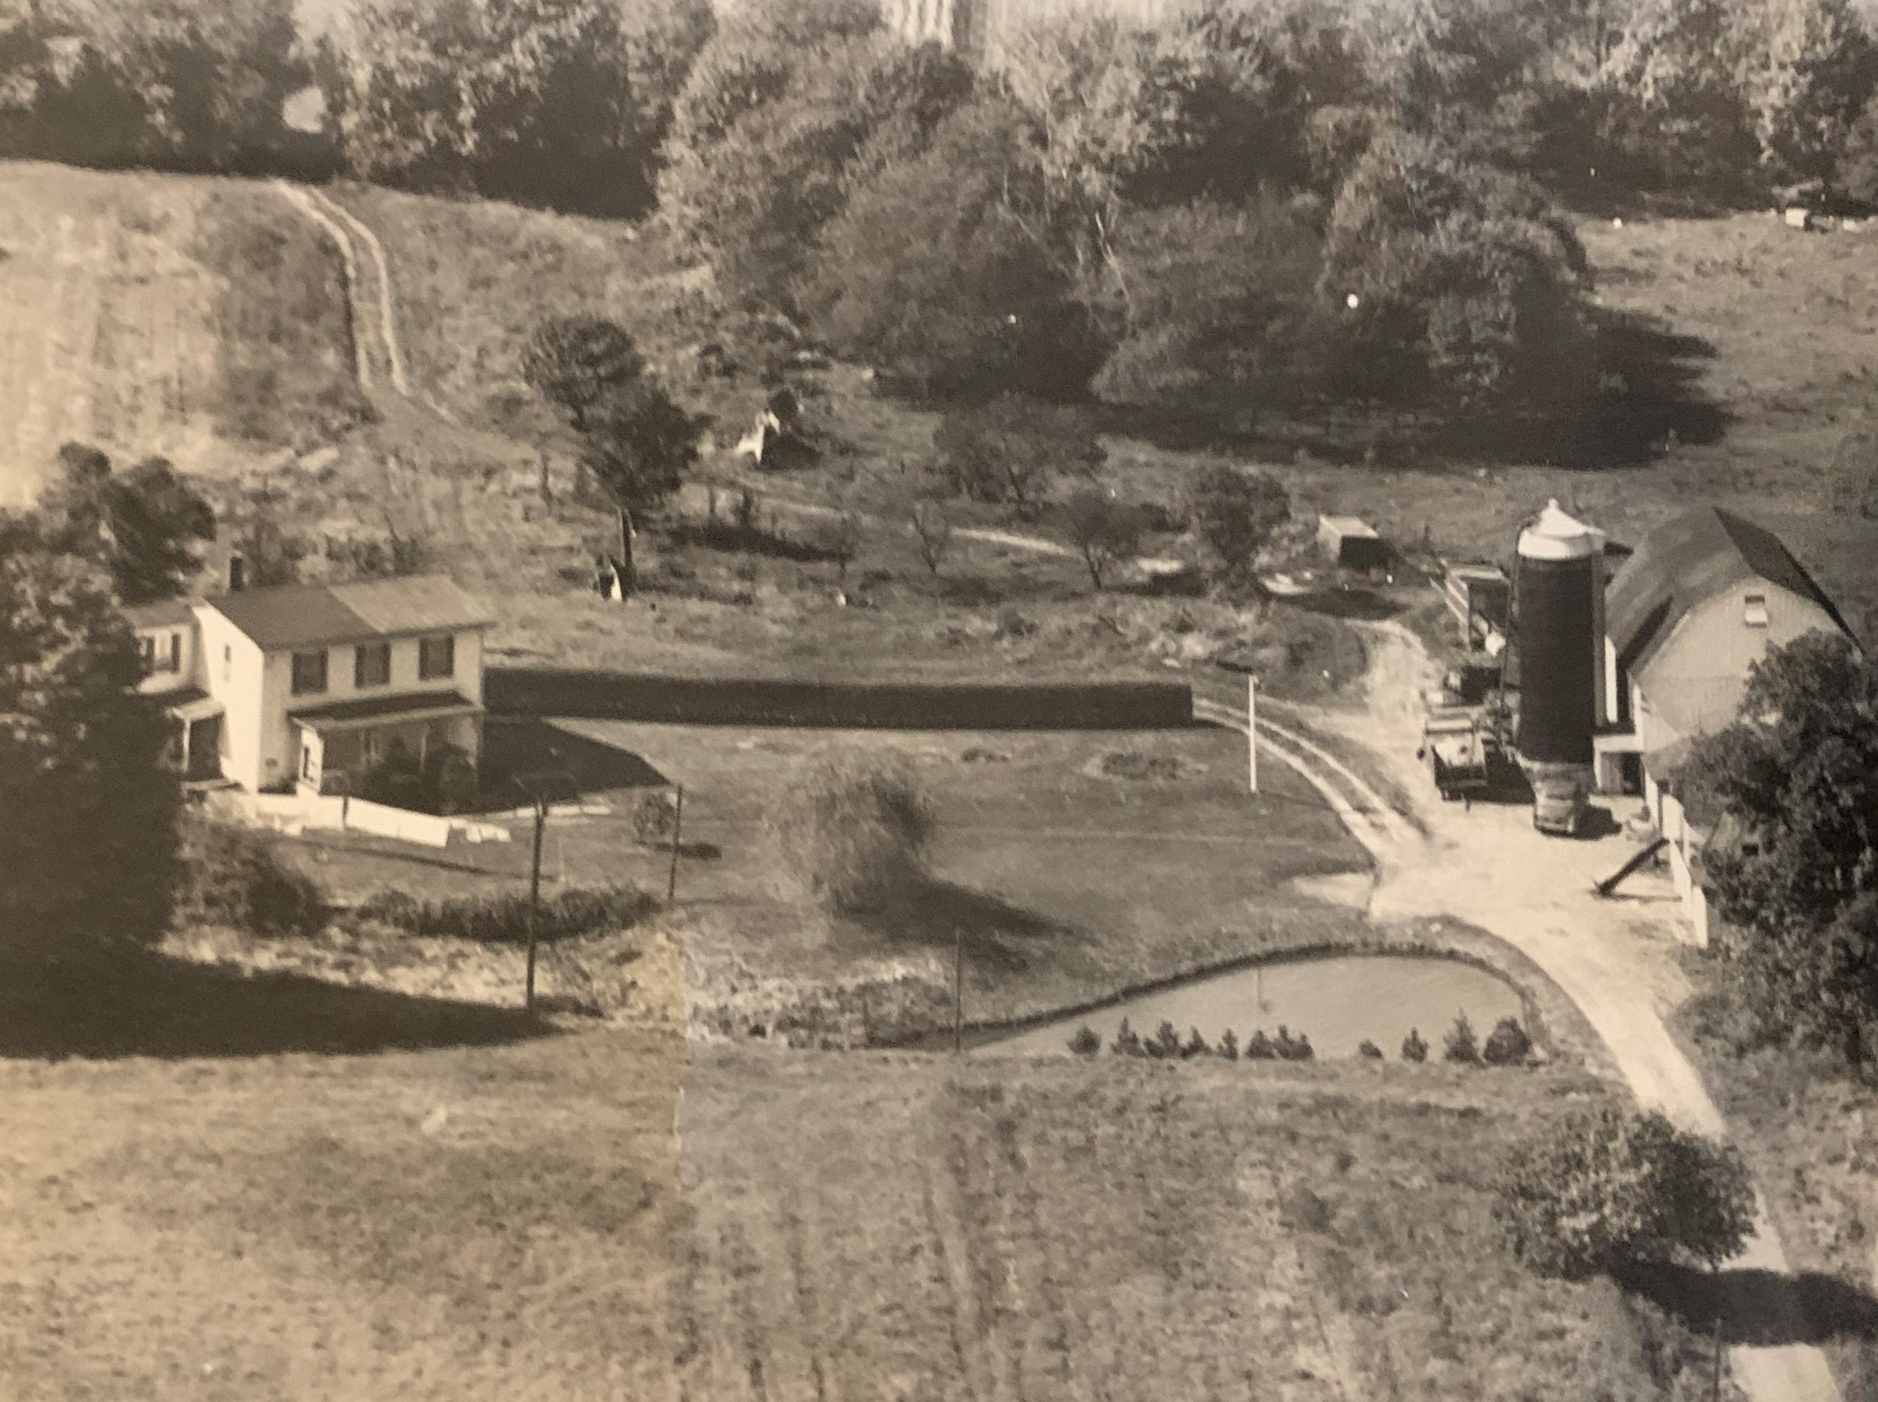
PAGE 2
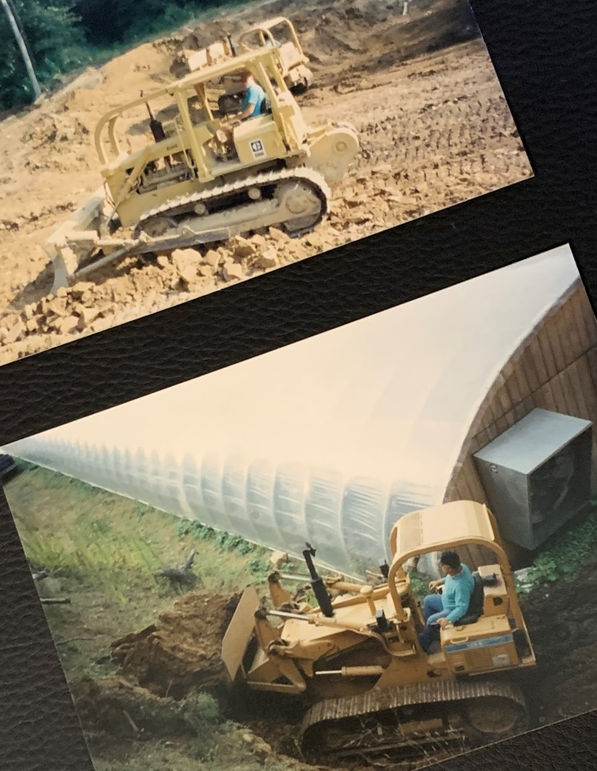
Jim is a very humble man but also has a heart of gold. He always has a hug or a handshake for everyone as well as kind words to brighten your day. Even though Jim has had some health issues in recent years, BUT he still keeps going and gives inspiration to many.
JIM ADDISON – FEATURED MEMBER #1
PAGE 4

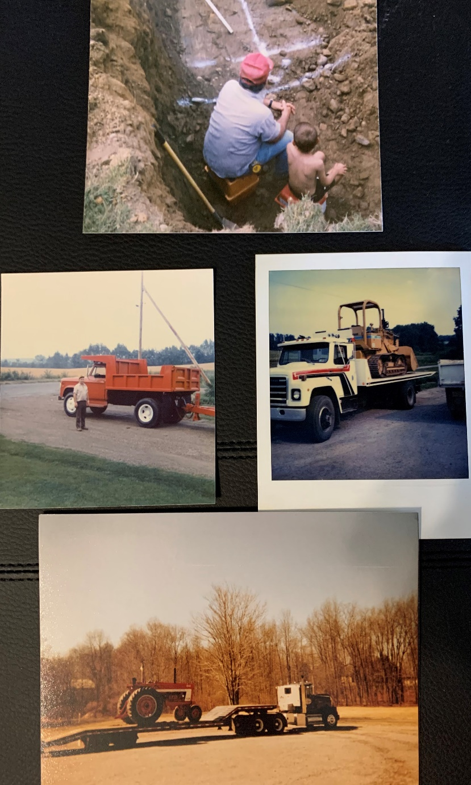
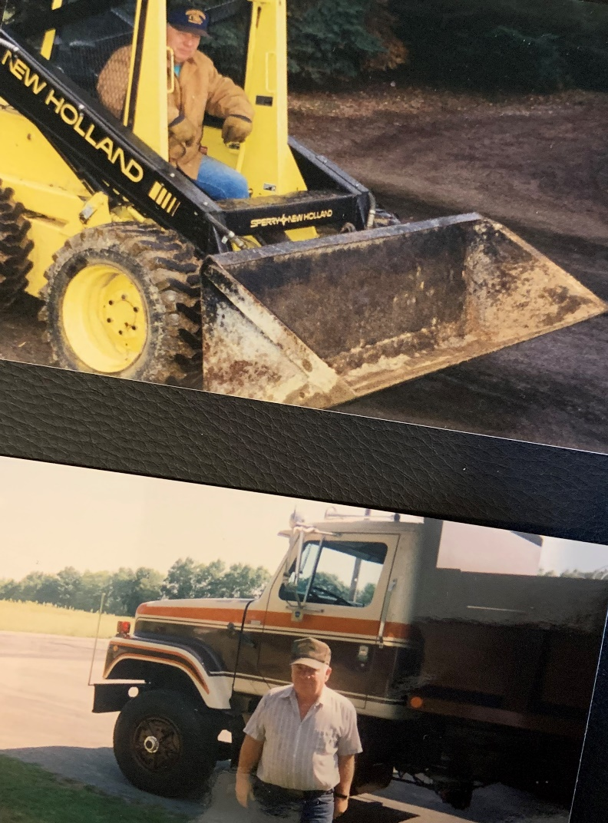
One of my most favorite memories of Jim since I’ve been the Executive Director of PALICA is one of our first State Conventions in Harrisburg and we were holding a live auction for our scholarship fund. Someone donated a beautiful porcelain doll as an auction item and a young girl in attendance wanted that doll more than anything – Jim quietly bid on that doll over several others and when he was awarded the doll, he walked over and gave it to that little girl and Christmas morning sat there right in front of all of us. That wraps up Jim Addison to me in a nutshell.

FEATURED MEMBER #2 – BARRY MUTZABAUGH Jr.
B.R. Mutzabaugh Jr. Excavating & Landscape Inc.


Barry is one of PALICA’s newest board members. While attending the 2020 PALICA Winter Meeting in State College, PA, Barry was approached by other board members and was asked to consider becoming a board member.
Barry resides on the eastern side of the state where many of the members reside on the western side of PA. We’re very thankful he agreed to join the board and attended his first meeting as a board member that same weekend. He’s our first member in a while with landscaping background so that’s also a nice addition to the group of mainly excavators.
We’ve found through spending time with Barry that where Barry is, the party isn’t too far behind! He and his family offered to host the summer picnic (all weekend) this past summer but of course, Covid 19 ruined that plan! We’re very hopeful we’ll be able to reschedule this fun sounding weekend next summer!
Barry started the company over 25 years ago with his wife Crystal. They incorporated in January 2015.
They offer full service excavating & landscape services. Barry handles the excavating aspect of the business while Crystal does more of the landscape & plant health care.

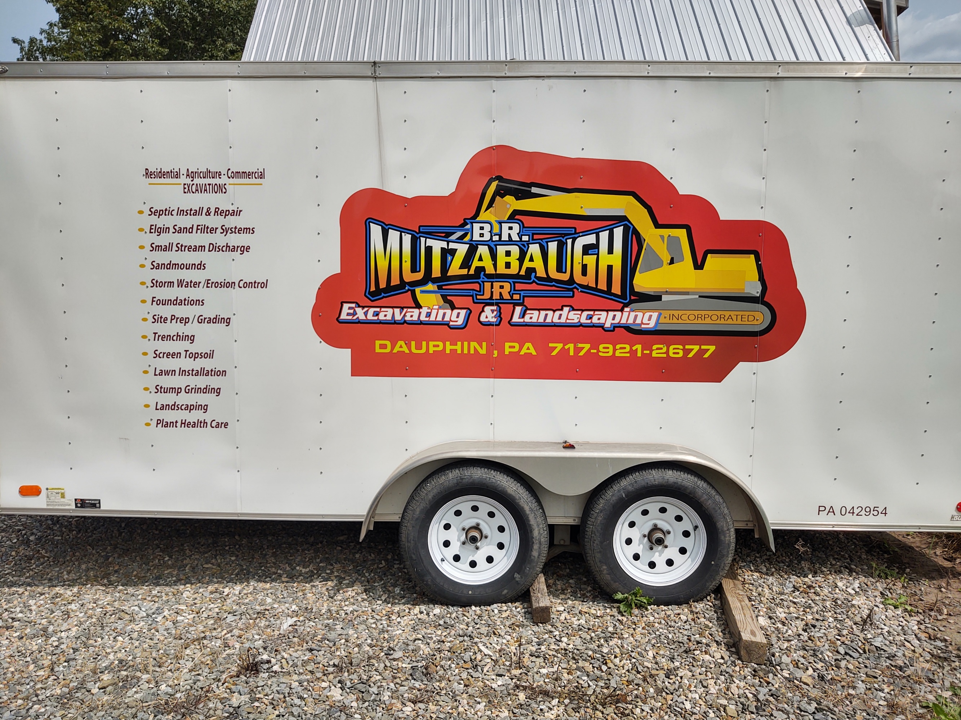
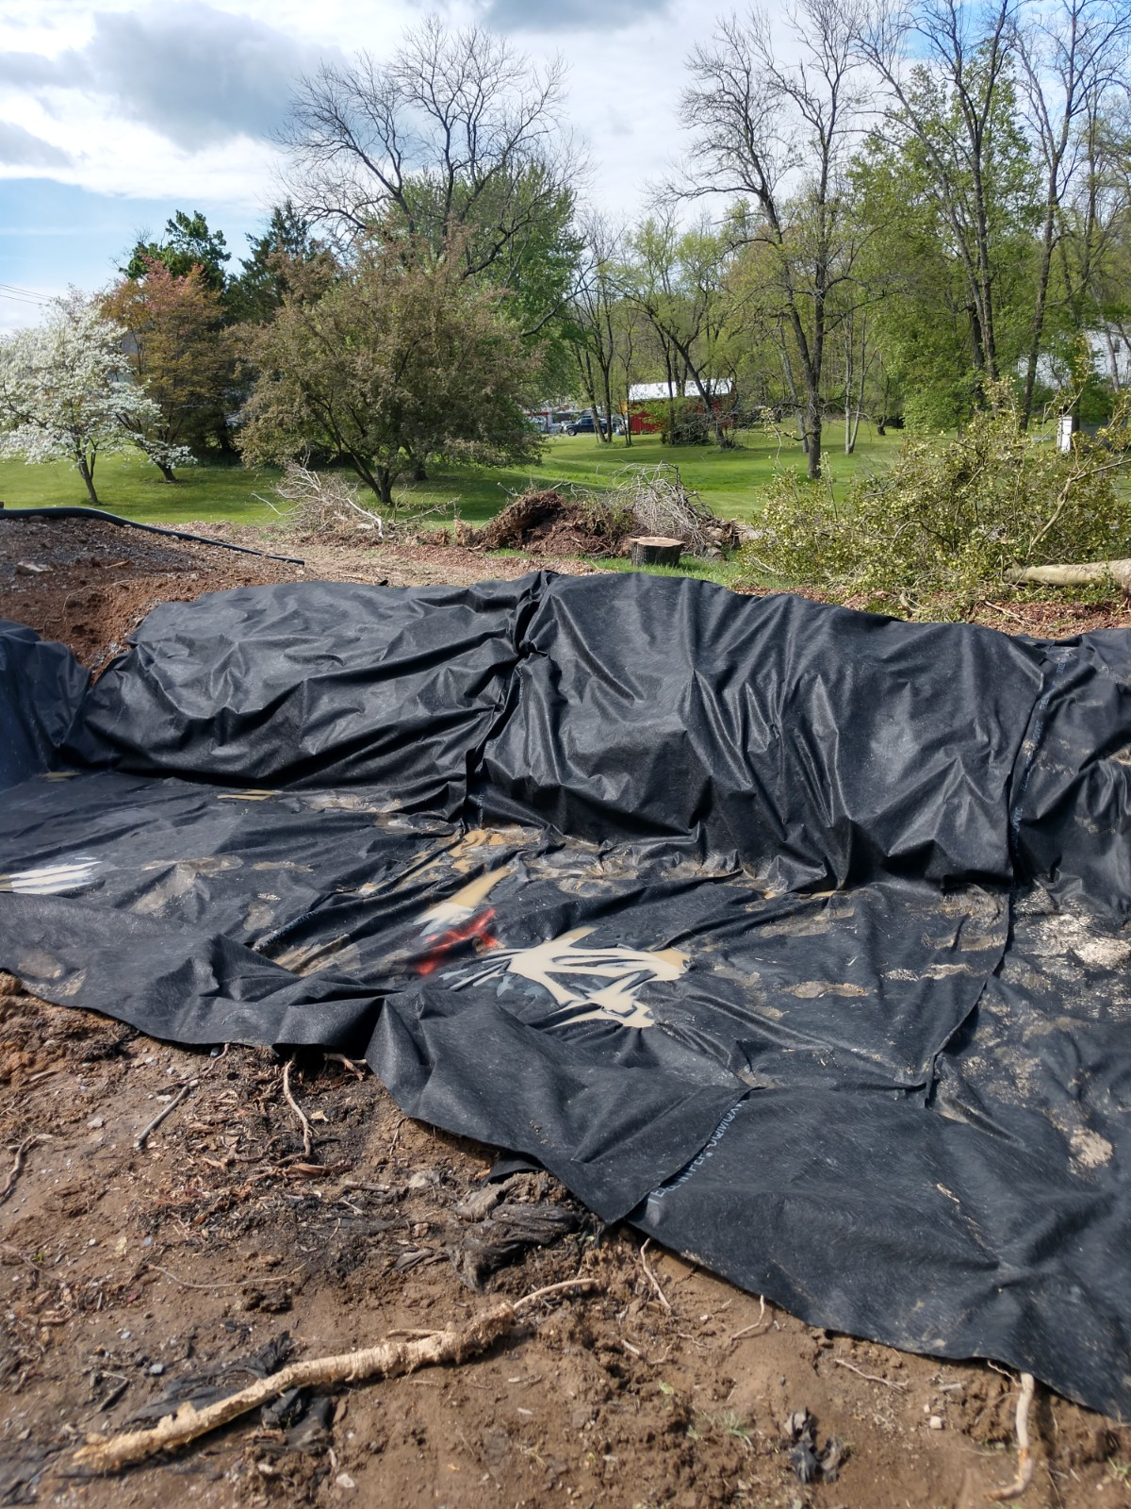
They will be married 25 years June 2021. Chloe is their only child & she graduates from Dauphin County Technical School in 2021. “She is studying Web Design, but wanted to go to college for animation.
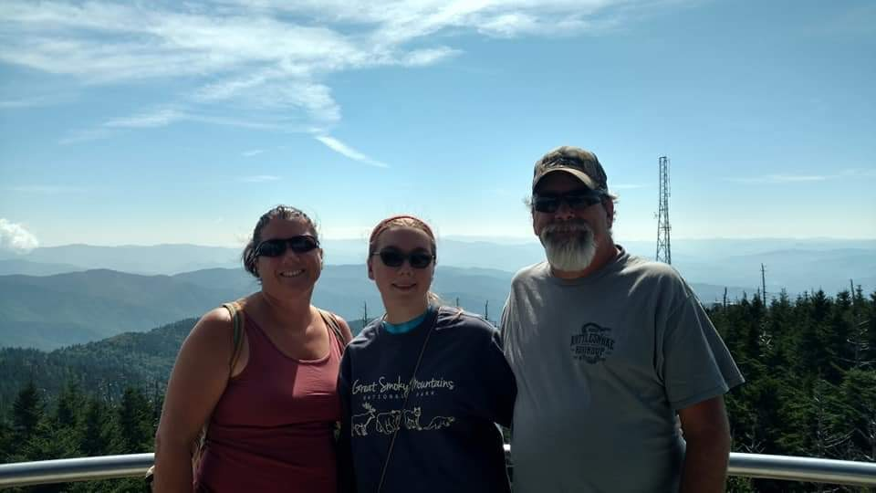
She has been dancing for 11 years (tap, Jazz & Musical Theatre). She is our artsy child... no idea where that came from. We love to travel to different locations; we are not the typical beachy family.”

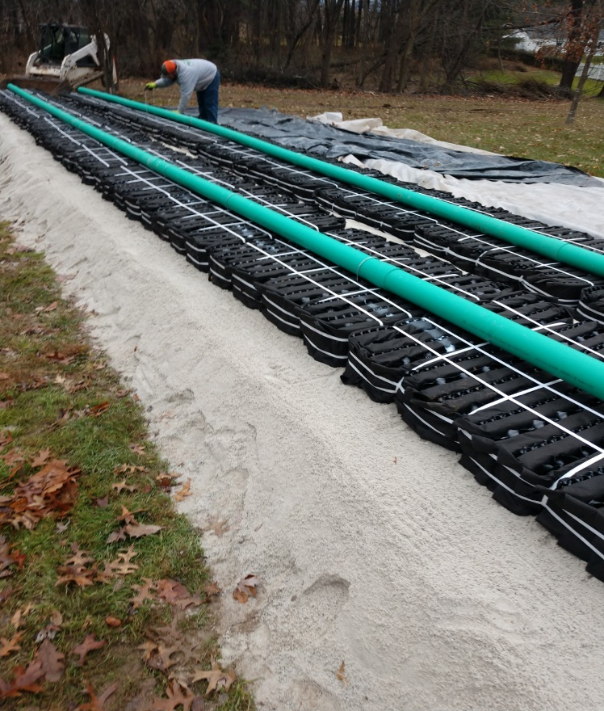

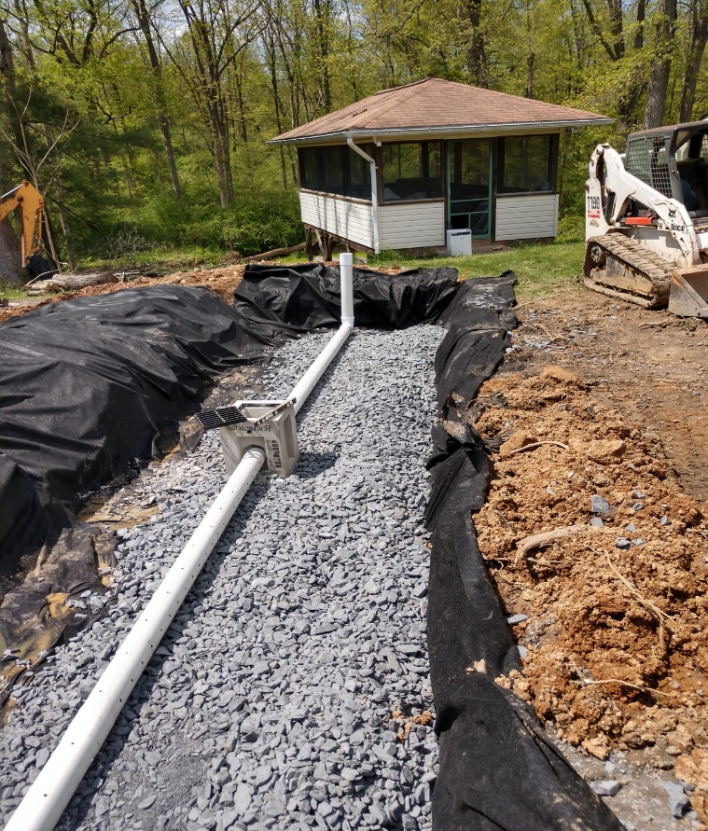
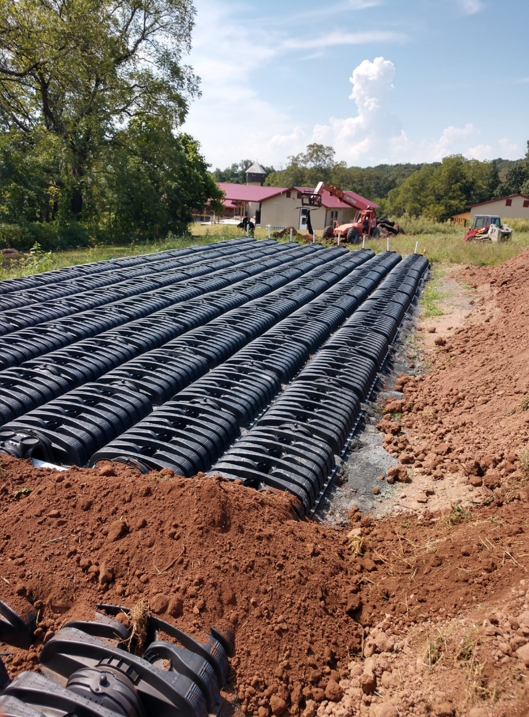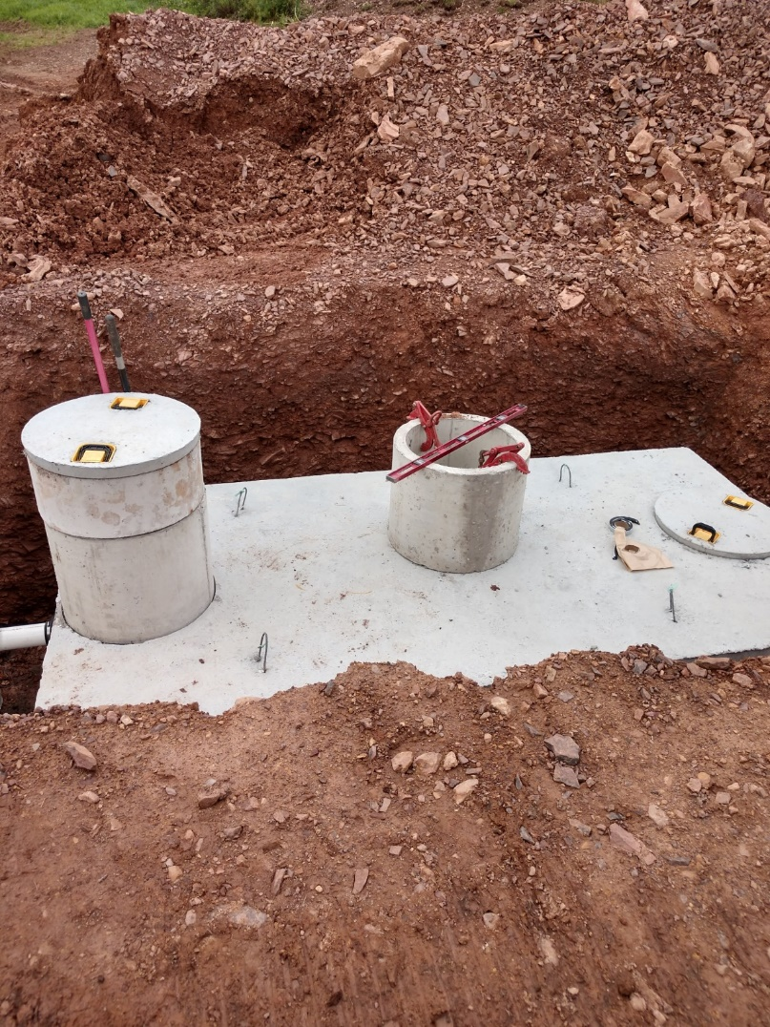

PALICA 2020 SCHOLARSHIP WINNERS!

Dear PALICA,


As a recipient of the 2020 Pennsylvania LICA scholarship, I wanted to thank
you for awarding me this scholarship. I was very excited to learn that I had
been selected as the winner of this scholarship. I am appreciative of your
support of my education. I am currently in my freshman year at the
University of Findlay studying Animal Science/ Pre-Veterinary.
I intend on graduating in 2024. Following my under-graduate studies,
I intend to continue my veterinary studies at a graduate school. Thanks to you,
I am one step closer to achieving my goals. Veterinary schooling is incredibly
Expensive and grueling, without this scholarship I would be in even greater
debt. Thank you again for your investment in students like myself
and in our education.
By awarding me the Pennsylvania LICA scholarship, you are allowing
me to focus on the most important aspect of school, learning. I hope that one
day I will also be able to help a student achieve their goals, like you have
helped me. Continuing my studies would not be possible without generous
support from scholarship sponsors like yourself. Thank you for making this
possible.
Sincerely,
Brianna Micsky
Congratulations to our two- ($1,000.00) scholarship winners this past summer: Miss Brianna Micsky (granddaughter of members Lawrence & Nancy Micsky), and Miss Keri Ferster,
(granddaughter of Mark Ferster).

Your contributions towards the PALICA Scholarship account have allowed the board to award many scholarships over the past many years and even increase the amount of the scholarships. If you haven’t already returned your dues yet, please consider making a donation on the donation sheet included with your invoice.
If you know of anyone who would like to apply for the scholarship for next year, give them the application, or tell them to go to our website and find the application with filing instructions and criteria.



PAGE 7

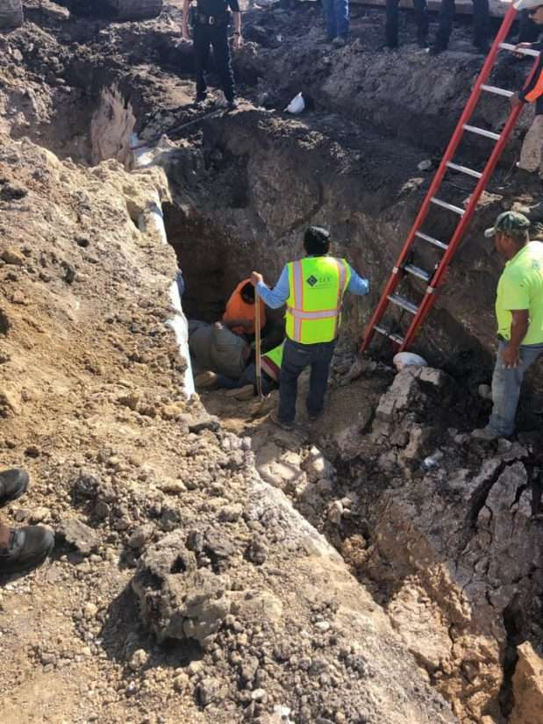
OSHA reveals leading causes of trench violations in construction
A PUBLICATION OF RANDALL REILLY
Emergency personnel respond to a fatal trench collapse December 3 in Gregory, Texas. Photo credit: San Patricio County Sheriff’s Office
- Placing spoil too close to a trench where rock and dirt could fall in on employees – 330 (28%)
- Failure to provide daily inspections of excavations – 302 (26%)
- Failure by the designated competent person on the jobsite to protect workers from potential cave-in – 106 (9%)
- Hazards created by water accumulating in a trench – 49 (4%)

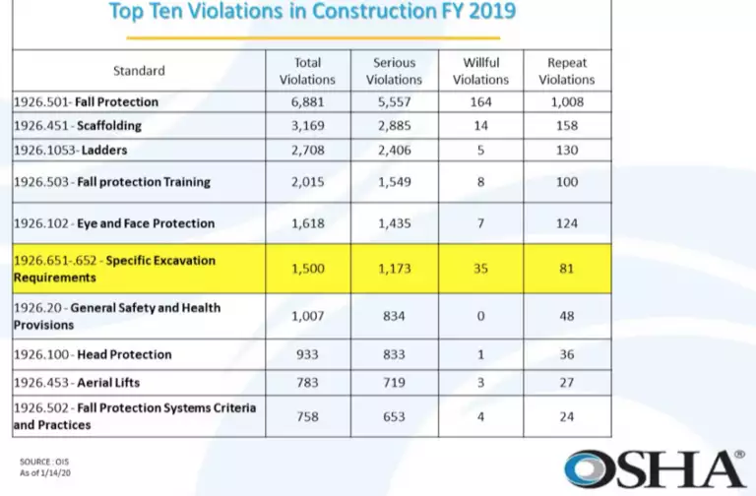
More inspectors stopping for trenches
Ketcham noted that since 2018, OSHA has placed a greater emphasis on trench safety, ramping up inspections on jobsites and its compliance assistance to the construction industry.
The national emphasis program followed a rise in trench deaths from an average of 17 fatalities a year between 2012 and 2014, to an average of 29 a year between 2015 and 2017. Fatalities dropped back to 17 in 2018, he said.
Excavation violations were the sixth-leading cause of citations issued on construction sites by the U.S. Occupational Safety and Health Administration in fiscal year 2019.
Of those violations, failing to provide trench protection was the leading cause for an excavation citation, according to data presented recently by an OSHA official.
Failing to protect a trench from collapse accounted for 805, or 67 percent, of the 1,173 citations for serious excavation violations OSHA issued between October 1, 2018, and September 30, 2019, according to Scott Ketcham, director of OSHA’s Directorate of Construction.
Ketcham provided the statistics at a May 28 webinar on trench safety hosted by the CPWR Center for Construction Research and Training. The event was a lead-up to June being designated Trench Safety Month by the National Utility Contractors Association. Thousands of workers are expected to participate June 15-19 in a Trench Safety Stand Down sponsored by NUCA.
The next leading causes for serious excavation violations, according to Ketcham, were: (Note: The citations overlap, so percentages and figures will add up to more than 1,173 or 100 percent.)
- Failure to provide a ladder or other proper means of entering and exiting a trench – 396 citations (34%)
- Placing spoil too close to a trench where rock and dirt could fall in on employees – 330 (28%)
- Failure to provide daily inspections of excavations – 302 (26%)
- Failure by the designated competent person on the jobsite to protect workers from potential cave-in – 106 (9%)
- Hazards created by water accumulating in a trench – 49 (4%)

“When asked the biggest contributors to trench incidents or collapses, 67 percent think there was a lack of proper training, and nearly 60 percent believe it’s a simple indifference to the safety requirements,” said Joe Wise, regional customer training manager for United Rentals Trench Safety. The survey was conducted by CPWR in conjunction with participants in United Rentals’ trench training programs.
Other contributors to trench incidents, according to respondents, were:
- Trying to stay on schedule – 66%
- Lack of understanding of OSHA excavation standards – 53%
- Tight budgets – 35%
- Language barriers – 21%
For Wise, one of the most telling survey responses involved the “competent person,” as required by OSHA standards to oversee and inspect trenching and excavation.
“More than 40 percent fail to see a trained competent person on their jobsite,” Wise said. “And this is something that is really needing to be changed.”
The competent person’s job is to inspect excavations daily and make sure they are safe, and remove workers when they are unsafe. That includes determining cave-in potential and the proper collapse prevention.
“There’s a lot of things the person has to be responsible for, but first and foremost, it’s conducting the soil analysis to know what that right protective system may be, whether it’s sloping, benching, shielding or shoring,” Wise said.
The survey also indicated most trenches lack proper protection. OSHA standards require that trenches and excavations 5 feet or deeper be protected.
“Sloping, benching, shoring and shielding – they work if they’re done properly,” Ketcham said. “They can prevent these tragedies from happening.”

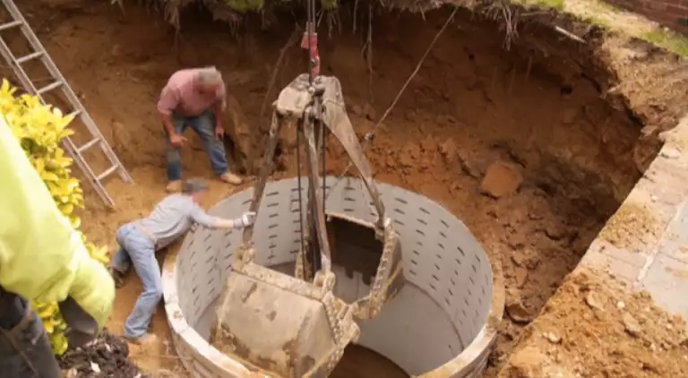
An OSHA-provided photo of a septic liner installation just before a fatal excavation collapse.
“This is a tragedy in the making moments after this picture was taken,” he said.
After the photo was taken, the bucket was going back into the excavation when the bottom collapsed beneath the workers. One of the workers died after being sucked down underneath the septic tank liner and buried. The worker who was holding onto the bucket was hoisted to safety.
“This is why we’re focusing in on trenching,” Ketcham said. “It happens in a second. And the conditions can lead to loss of life very quickly.”
Before launching its national emphasis program on trenching in 2018, OSHA examined data from 120 trenching incidents between 2013 and 2017. The agency found that more than half of the incidents occurred at these types of construction sites: single-family or duplex dwellings, pipeline, and roadwork.
That helped OSHA determine its enforcement as well as compliance assistance, Ketcham said.
“Our compliance, safety and health officers are out, actively engaged,” he said, “and if they see a trench, they’re going to stop … and they’re going to evaluate whether or not there are hazards.”

Lack of protection, competent person
A recent survey indicates that many construction sites are still not protecting workers from cave-in and do not have a supervisor trained in trench safety on site.

Stand down
Last year, more than 50,000 workers participated in the Trench Safety Stand Down, which has been an annual event since 2016.
This year’s event took place from June 15 to 19. The stand down week consists of a series of organized events held by NUCA and member and nonmember industry professionals. Industry safety professionals hold safety training, educational seminars, live demonstrations of trench rescues and other activities related to trench safety.
In summing up the importance of better training and education for the industry, Wise reiterated the dangers facing workers in trenches.
“It just takes a second for something to go tragically wrong,” he said. “And there you have now a worker who’s being asked to make that decision: do I dig them out or do I let them stay there and try to dig themselves out? That’s a horrible situation to put any worker in. And there’s responsibilities and systems in place to prevent that.”

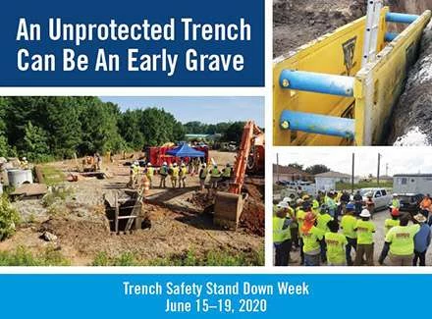

Ketcham noted, too, that the competent person could also require protection in trenches less than 5 feet deep if conditions warrant it. He mentioned an incident involving a worker in a 3-foot-deep trench that collapsed. “He was leaning over, and he was severely injured – ruptured spleen, broken back.”
More training needed
“We see that the best practice in the industry is repeated training,” Wise said, “that they have anywhere from one to three years for their competent person and not just have a one-and-done achievement of that certification that they’re after.”
Wise presented these highlights from the survey:
- Trench protection – 23 percent said they never see trench protection, such as sloping, benching, shielding or shoring, on jobsites. 55 percent occasionally see it. And 22 percent say they frequently or always see it.

- Competent person – 39 percent say they always see a competent person trained in trenching. 27 percent say they frequently see one. 31 percent occasionally see one. And 3 percent never see one.

- New workers – 21 percent say they frequently see incidents where new workers are exposed to trench and excavation work without proper competent-person supervision. 53 percent say they see this occasionally. 3 percent say they always see this. And 23 percent say they never see new workers in trenches and excavations without proper competent person supervision

“We’ve also found that incidents often involve contractors who may be inexperienced or may be new to trench work,” Wise said. “Again, it goes back to education.”


THIS IS MACK’S 4TH QUARTER INCENTIVE PROGRAM UPDATED BENEFIT.
PAGE 14

****Lifestyle Health Plans has updated their benefit for LICA members – please read the next 2 pages to get more info

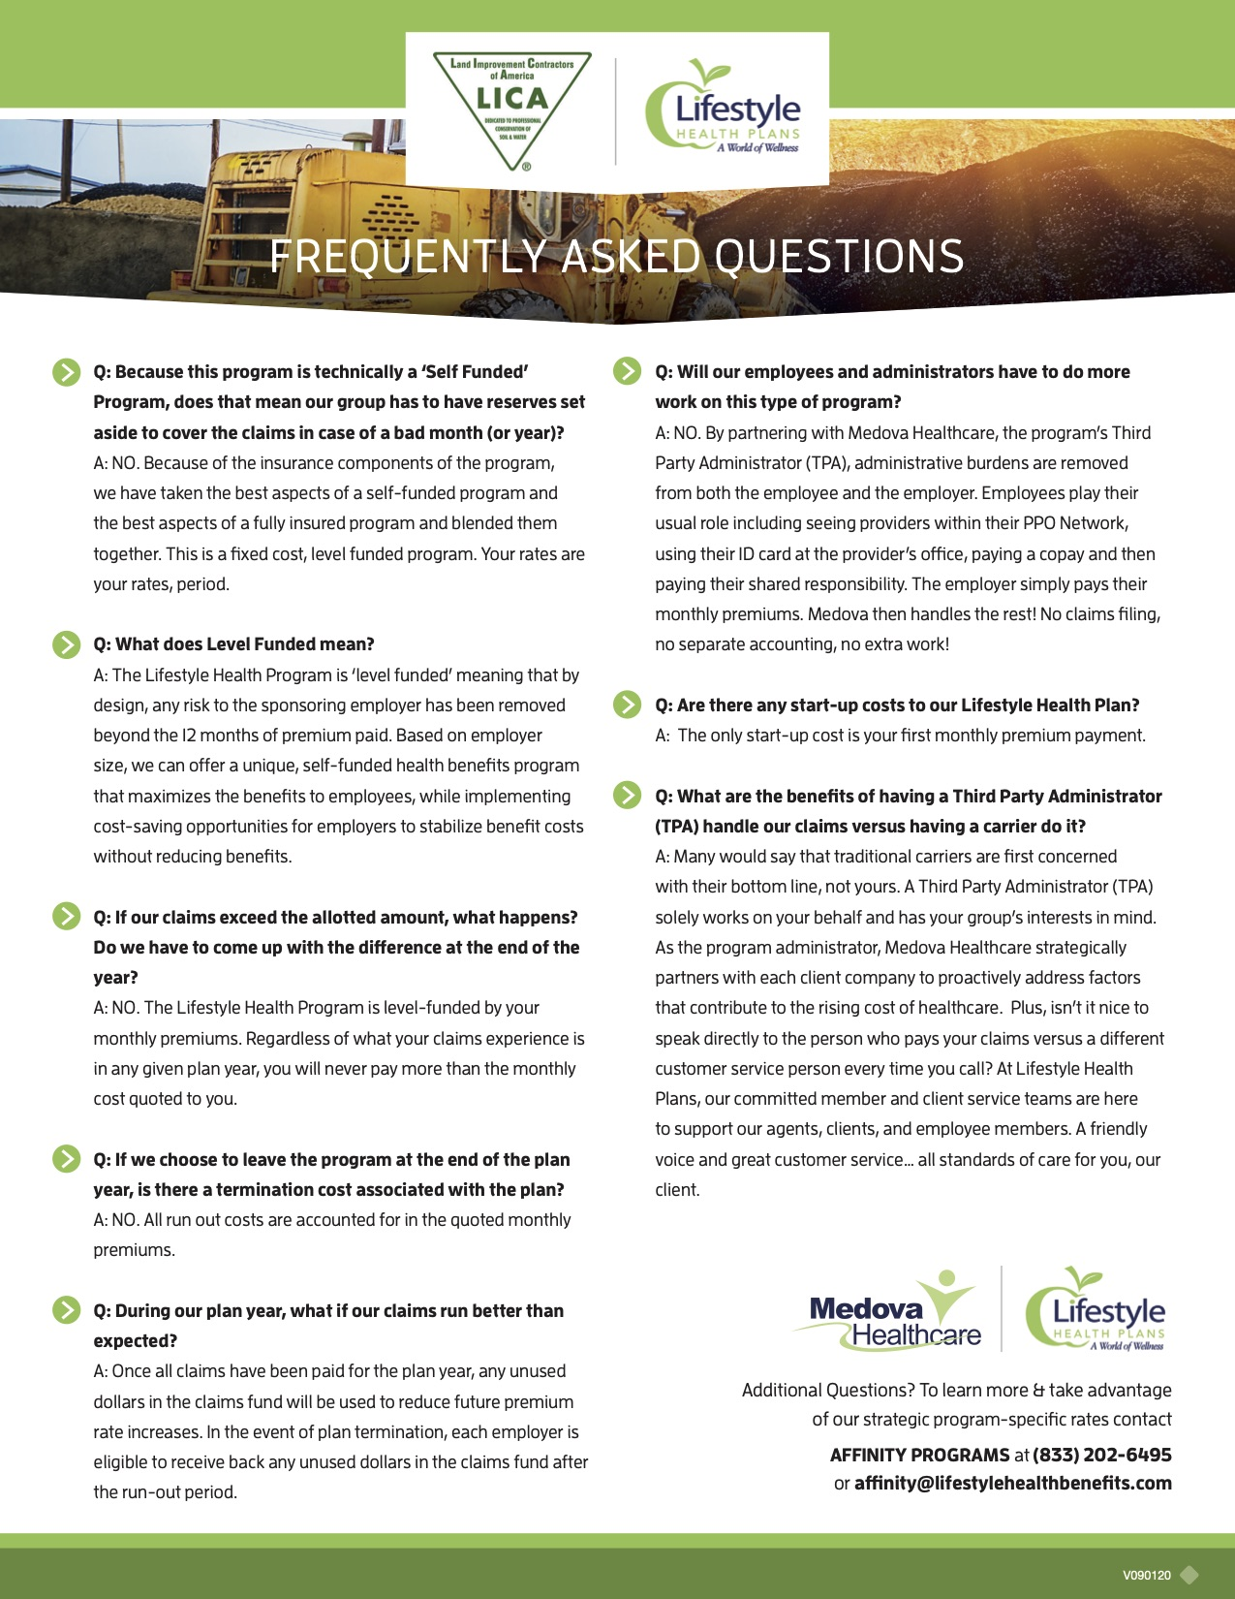

BRIDGEWELL HAS UPDATED THEIR BENEFIT AS WELL SO PLEASE TAKE THE TIME TO REVIEW THE INFORMATION ON THIS FLYER AND CONTACT THE NUMBER BELOW FOR MORE INFORMATION.
PAGE 16
PAGE 15
ASSOCIATE MEMBER RECOGNITION PAGE - Gilbert’s Risk Solutions & Ms. Colleen Pituch


While attending the Winter Meeting 2019 in State College, I had the pleasure of meeting many of the current members. I felt so honored and excited to be an Associate Member of such and outstanding organization. Between the event itself and the outstanding classes and speakers, along with the members and the overall experience, I believe that every member of PA LICA can benefit. But what was even more impressive to me, was the respect and appreciation that the members show for each other, along with your dedication and commitment for what you do.
Strength in numbers is an often used phrase, and means different things to different people. But to me, this means that the larger this chapter of LICA grows, the more unstoppable you can become.
Colleen has joined the PALICA Board of Directors this past spring and has been extremely helpful in many of the avenues we’ve tried to make contact with existing and potentially new members through all the obstacles of COVID-19. If you are interested in learning more about the UFG Insurance Program, please contact Colleen at number below for more information.

888888
Gilberts Risk Solutions and I found each other, and never looked back. Their culture and family style organization have made me feel at home, and so proud to be a member. With over 390 years of collective experience from just one department, it’s easy to see why we have the best staff. Teamwork is at the top of our cultural identity, and I fully believe that together we can do great things. My insurance experience spans over 20 years with a large focus on Construction, and how to make companies more profitable within their insurance program. I take pride in the work that I do for Gilberts, for my Clients, and knowledge base that I have gained throughout my career.
I’m excited to be a part of the Pennsylvania Land Improvement Contractors of America Organization, and offering assistance under the Executive Director, Joanie Micsky. My goals are to help PA LICA increase its membership and to help grow and strengthen the UFG Prins Program, along with providing education in my area of expertise to members, when needed. With a minor in Marketing, I feel as those I can help Joanie and PA LICA in their efforts to grow your already successful organization, into a much larger family of members.

PAGE 17
PAGE 7
PAGE 18
Page 12
Truck crashes cut by 50% for these major fleets using driver assistance tech 99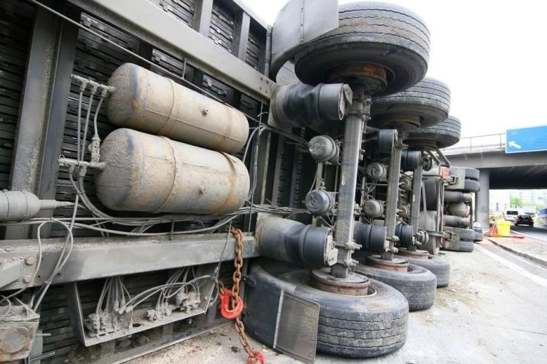Operating large trucks safely and reducing serious crashes have never been more difficult, as trucks are surrounded by smartphone-distracted motorists who are driving more and increasing congestion, which raises the frequency of collisions.
Check out the newest BENEFITS -- updated October 2017!

But as much as technology can be the cause of the problem, it also can offer potential solutions for commercial vehicle operators to combat increased driving risks through platforms such as automatic emergency braking (AEB) and advanced driver assistance systems (ADAS).

Speaking as part of the Federal Motor Carrier Safety Administration’s Truck Safety Summit on Aug. 5, Greer Woodruff – senior vice president of safety, security and driver personnel transport for J.B. Hunt – and other panelists discussed the benefits of AEB and ADAS.

AEB includes forward collision warning (FCW) technology that helps prevent and mitigate front-to-rear crashes. The technology will be standard in most passenger cars by late 2022, but its filtration into trucking to-date has been voluntary.
ADAS includes AEB and technologies such as adaptive cruise, intelligent headlights, lane-keeping assist, blind spot detection, automatic wipers and more.

Woodruff said as a starting point that he would like to see all heavy-duty truck manufacturers voluntarily make AEB standard on all new vehicles. He also touted the safety benefits that J.B. Hunt has seen by using ADAS to help drivers across all experience levels stay safe, noting that anyone is susceptible to lapses in judgment depending on the conditions.

The Lowell, Arkansas-based company has AEB and FCW installed in 98 percent of its tractors and attributes a 50 percent reduction in rear-end collisions to the technology, along with reductions in accident severity, equipment downtime and driver turnover. Between 45 percent and 50 percent of new heavy-duty vehicles sold today are equipped with AEB spec’d by fleets, with many of them going to the largest carriers that already have seen the benefits of reduced at-fault rear-end accidents.

Camera- and radar-based collision mitigation platforms detect slower-moving or stopped vehicles ahead and monitor traffic around the truck, but those rely on AEB to slow down the rig when the system determines a crash is imminent.
Schneider National began spec’ing active safety systems eight years ago on new tractor orders, as they are not available on the aftermarket and have to be spec’d with the OEM. Within the first three years, the Green Bay, Wisconsin-based fleet saw a 68 percent reduction in rear-end accident frequency and a 95 percent reduction in severity.

“If it’s not eliminating the crash, it is mitigating the impact of it,” said Thomas DiSalvi, vice president of safety, driver training and compliance for Schneider. However, carriers still rely on qualified well-trained drivers behind the wheel, using technology only to enhance their abilities.

WE NEED TO ASK YOU ALL FOR A FAVOR……
Would you consider going to our web page and leaving a Google review for Pennsylvania LICA? In today’s world, many people do business solely based on review. I for one shop that way…..Reviews can make or break a business as many of you probably know.

You can Google Pennsylvania LICA and it will take you to our page where you can leave a review on the right-hand side below the Association name and information. If you have found some class, training, convention or benefit that has helped you in your business since you’ve been a member, we’d really love to have you share your experience. Associate members can also leave reviews about how your feelings about partnering with PALICA and our membership.
THANK YOU SO MUCH!!!
“The number-one safety feature in that truck is the guy behind the wheel,” said Steve Fields, a driver for Overland Park, Kansas-based YRC Worldwide and an America’s Road Team Captain.
Jamie Maus, vice president of safety and compliance for Werner, said AEB has cut the Omaha, Nebraska-based carrier’s accident frequency by over half and reduced severity greatly.
“What once was a fatal accident is now an injury accident,” she said. “An injury accident is now a property damage accident, and property damage accidents have become nonexistent.”
Maverick USA first deployed active driver assist technologies in 2004 with early collision warning systems, also seeing a roughly three-year window of effectiveness at the onset via the Little Rock, Arkansas-based fleet’s trade cycle. Dean Newell, vice president of safety and training for Maverick, said that as the carrier added more layers such as AEB to the technology suite, the company has had only six rear-end accidents in the last 31 months: three in 2018, three in 2019 and none this year to-date.
“In my mind, it works,” Newell said, adding the system is now standard fleetwide. “With the [return on investment], you don’t know what you’ve prevented, but once you look at the data, it becomes clear.”
Regulators last weighed in on truck safety platforms when the National Highway Traffic Safety Administration mandated stability control in 2017, but early adopters of AEB urged FMCSA to explore the benefit of more widespread adoption.
“[It’s going to take] the OEMs working together to make this a standard instead of just an option,” Newell said. “I think a push from FMCSA on that side would be a benefit. Data shows that it works. In reality, it’s the right thing to do.”
Ritchie Huang, Daimler Trucks’ executive manager of advanced safety systems and autonomous driving, said the OEM believes that AEB and ADAS could address 69 percent of all crashes.



Page 15


PAGE 22


